**Title: MAL Basket**

**Team: Hola Amigos**

**Team Members:**

**-**Nabin Timsina

-Dikshyant Baral

- Kushal Thapa Magar

## **ABSTRACT**

In Nepal, farmers face various challenges, including limited market access and a lack of direct connections with urban consumers, while city dwellers, particularly those engaged in terrace farming, struggle to find organic and sustainable fertilizers. To address these issues, **EcoGrow Exchange** presents an innovative digital platform designed to connect rural farmers who produce organic manure with urban gardeners in need of high-quality fertilizers. This platform enables seamless transactions, where farmers can list their manure products, and urban gardeners can easily find and purchase the necessary nutrients for their urban farms.

EcoGrow Exchange aims to empower Nepal’s agricultural ecosystem by providing farmers with an additional income stream while promoting sustainable agricultural practices in urban areas. Through a user-friendly interface, farmers can manage their manure listings, set prices, and track sales, while buyers can browse products, compare prices, and choose from a range of delivery options. With integrated educational resources, the platform also encourages better composting practices for farmers and effective manure use for urban gardeners.

The project leverages technology to create a sustainable cycle of resource exchange that benefits both rural producers and urban consumers, contributing to Nepal's overall environmental and agricultural resilience. By connecting farmers directly to urban terraces, EcoGrow Exchange fosters a thriving, green community and aims to promote a circular economy focused on organic, locally sourced farming solutions.

**Keywords:**  *Sustainable Agriculture, Rural-Urban connection, Organic Manure, Terrace Farming, Eco-Friendly MarketPlace*

## **CHAPTER 1**

#### **1.1. Background of the Research/Project**

#### Agriculture has long been the backbone of Nepal’s economy, with the majority of its population engaged in farming activities. However, despite its significance, farmers in rural Nepal face numerous challenges, including limited access to markets, lack of infrastructure, and financial instability. One of the pressing issues in both rural and urban settings is the effective management of organic waste, particularly animal manure. While farmers have abundant manure produced from livestock, urban gardeners, especially those involved in terrace farming, face difficulties in accessing organic fertilizers that are essential for growing sustainable, healthy crops.

With the rapid urbanization of Nepal, cities like Kathmandu have seen an increase in terrace farming, where urban dwellers are growing crops on rooftops and small plots of land. These gardeners require high-quality, organic manure to fertilize their plants, but the supply is often inadequate, expensive, or difficult to obtain. This project proposes an innovative solution—**Mal Basket**, an online platform that bridges the gap between rural farmers producing manure and urban gardeners who need it. By leveraging technology, this platform aims to create a more efficient and sustainable marketplace for organic fertilizers, ensuring that both farmers and urban gardeners benefit from a more direct and efficient supply chain.

#### **1.2. Statement of the Problem**

#### The agricultural sector in Nepal faces a disconnect between rural farmers, who produce large amounts of organic manure, and urban consumers, particularly terrace farmers, who need affordable and sustainable fertilizers. This mismatch creates inefficiencies in the market, as farmers often lack a direct outlet to sell their manure, and urban gardeners struggle to find affordable, high-quality organic fertilizers. Additionally, urbanization has led to an increased demand for organic farming products in cities, but the supply remains fragmented and unreliable. The lack of an organized platform to connect these two groups has hindered the growth of sustainable agricultural practices in urban environments.

#### **1.4. Project Objectives**

The main objectives of this project are as follows:

1. **Create a Digital Marketplace**: Develop a user-friendly online platform where rural farmers can list and sell organic manure to urban gardeners engaged in terrace farming.
2. **Promote Sustainability**: Facilitate the exchange of organic waste from rural areas to urban gardens, encouraging eco-friendly farming practices and contributing to the reduction of waste.
3. **Provide Educational Resources**: Offer guidance for both farmers on manure production and urban gardeners on how to use organic fertilizers effectively.
4. **Ensure Accessibility**: Provide an efficient and accessible platform that simplifies the process of buying and selling manure, improving accessibility for both parties.
5. **Create Economic Opportunities**: Empower farmers by providing an additional income stream and help urban gardeners grow healthy, sustainable crops.

### 

**CHAPTER 2**

## **SYSTEM DESIGN AND ARCHITECTURE**

Fig: Use Case Diagram

**CHAPTER 3**

## **EXPECTED OUTPUT**

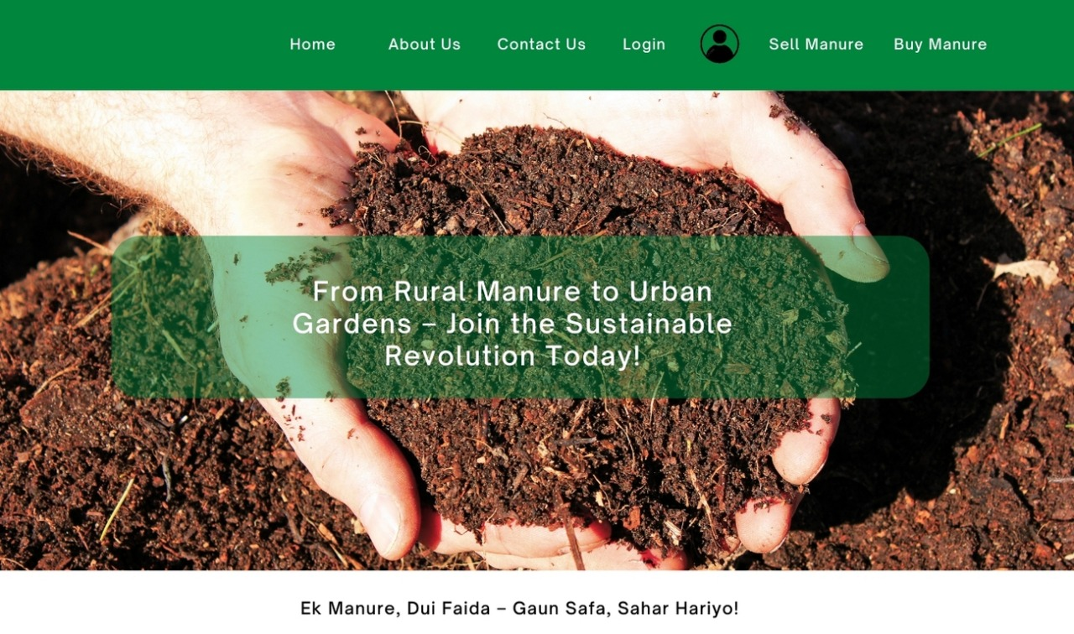

Fig: Sample of home page of website

**CHAPTER 4**

## **CONCLUSION**

The platform represents a significant step toward bridging the gap between rural farmers and urban gardeners in Nepal. By leveraging technology to facilitate the trade of organic manure, the platform not only empowers farmers to gain better income from their manure but also supports urban gardeners in sourcing eco-friendly fertilizers for their terrace farming practices. This system is designed to enhance agricultural sustainability, contributing to both economic and environmental well-being.

By incorporating user-friendly interfaces, efficient transaction management, and a secure database structure, the system promises to streamline the buying and selling process of manure, helping both rural and urban communities.

In conclusion, **MAL Basket** serves as a crucial tool for promoting sustainable agricultural practices in Nepal. It empowers farmers to monetize their organic waste while providing urban gardeners with essential resources for urban farming, ultimately contributing to Nepal’s agricultural growth and environmental sustainability. As the platform expands and evolves, it holds the potential to revolutionize how organic farming resources are exchanged, further boosting Nepal's agricultural sector.